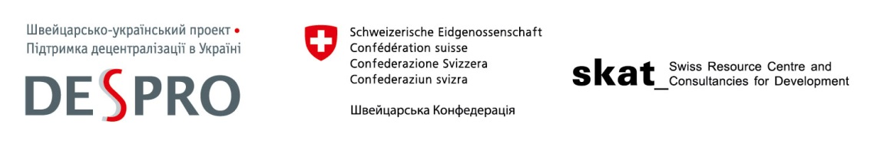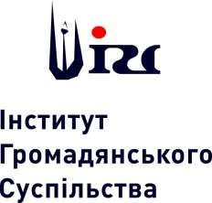
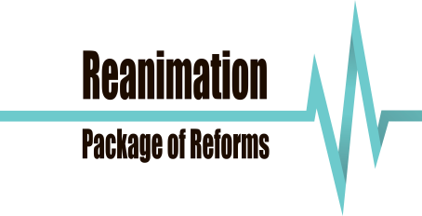
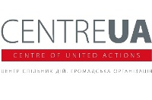

December 15, 2015
Parus Business Center, 2 Mechnykova St.

FORUM
“25th Anniversary of the Local Self-Government in Ukraine:
High Time for Decentralization”

10:30 a.m. - 11:00 a.m. Registration. Welcome coffee.

11:00 a.m. – 11:25 a.m. Opening of the Forum

- Holger Tausch, Director of the Swiss Cooperation Office
- Berend de Groot, Head of Cooperation, EU Delegation to Ukraine (TBC)
- Jed Barton, USAID Mission Director

Moderators:
- Hanna Bezulyk, journalist

11:25 a.m. – 12:45 p.m. Panel discussion “Kyiv Does Not Know Any Better: Challenges and Solutions Within the Local Self-Government Reform”

Panelists:
- Volodymyr Groysman, Chairman of the Verkhovna Rada of Ukraine (TBC)
- Vyacheslav Nehoda, First Deputy Minister of Regional Development and Housing and Utilities
- Anatoliy Tkachuk, Director of the Civil Society Institute, RPR expert on the decentralization and local self-government reform
- Olena Boiko, Member of the Verkhovna Rada Committee on State Building, Regional Policy and Local Self-Government
- Yuriy Bova, Mayor of Trostianets
- Oleksandra Sheremetyeva, Mayor of village Omelnyk, Poltavskyi region

12:45 p.m. – 1:45 p.m. Panel discussion: “Constitutional Amendments as a Key to a Comprehensive Reform of Decentralization”

Panelists:
- Yuriy Klyuchkovskyi, Member of the Constitutional Commission
- Ihor Koliushko, Chairman of the board of the Center of Policy and Legal Reform, RPR expert on the constitutional and administrative reforms
- Yuriy Hanushchak, Director of the Institute of Territorial Development, DESPRO expert, and RPR expert on the reforms of decentralization and local self-government
- Petro Stetsiuk, Judge of the Constitutional Court of Ukraine
- Victoria Ptashnyk, Member of the Verkhovna Rada Committee on economy policy, Member of the Constitutional Commission

1:45 p.m. – 2:00 p.m. Final conclusions of the moderators

2:00 p.m. – 3:00 p.m. Reception

Working languages: Ukrainian/English

For more details please contact: Olena Halushka +38 097 653 19 89.

